**OKLAHOMA STATE UNIVERSITY**

**STILLWATER**

**Stillwater, April 29, 2021**

**IEM 4013 Operations Research**

**Redefining Nebraska Political Districts**

**Team Name MMJ**

**Grilliette, Jayden CIWID 82193071**

**Piña, Marco CIWID 20145999**

**Velez Grau, Monica CIWID 11311785**

1. **Executive Summary Letter**

Today, Nebraska has three political districts, and this report intends to confirm the hypothesis that the current districts can be improved to avoid gerrymandering and to propose a new separation of political districts to fulfill the requirements that ensure no gerrymandering.

We formulated the objective function, ensuring upper and lower population bounds were within 1% deviation (+/-0.5%) from the ideal population. The constraints were designed to comply with Nebraska’s constitutional requirements looking for compactness, contiguity of the districts, preservation of political subdivision (counties), and preservation of metro and urban areas. After the mathematical model was defined, the code was run using Anaconda Python 3.8.5, Jupyter Notebook version 6.1.4, and Gurobi version 9.1.2 and its modules as the solver optimizer program. The solver program draws maps that comply with the code given, however, by using ArcGisPro, we include geographical information about scale, north, etc. that helps to understand how the code works with the different levels of constraints.

In conclusion, our model redefined Nebraska’s political districts. The shape of the districts and the quantity of counties in each district changed, allowing cleaner cut lines. The model proposed by the team changed the distribution of the counties. We found District One changed from 17 to 6 counties, District Two changed from 2 to 15 counties, and District Three from 75 to 72 counties. The model developed by the team, allowed Sarpy County to be a single unit in District Two, eliminating the split issue that was present in the former model and provided cleaner district lines.

1. **Introduction**

Redistricting is something that occurs every 10 years based on U.S. Census data. Redistricting is very important as it can have a big impact on who our elected officials are at the state and federal level. By impacting who is in office, it also influences government policies and legislation. Therefore, when redistricting a state, it is important to ensure every citizen has an equal opportunity to be represented.

It is imperative that new districts follow state and federal laws. The laws are typically that everyone in every district has an equal voice in government legislation. The requirement, which every state has to follow, comes from the "one man, one vote" principle, which means all districts should be equal in size to the furthest extent possible.

It is important to follow state and federal government guidelines when redistricting a state. The goal for the project is to find optimal districts for Nebraska that ensure they are continuous, contiguous, compact, and follow all state and federal laws. The goal is to find districts that equally represent the entire population of Nebraska and avoid gerrymandering.

1. **Criteria**

According to the website of the National Conference of State Legislatures (NCSL) (ncsl.org) federal redistricting shows compliance with the following requirements:

**Federal redistricting**

**● Required** All states must comply with the federal constitutional requirements related to population and anti-discrimination. Nearly all congressional districts within the states must be as equal in population as practicable.

**● Prohibited** Federal redistricting prohibits plans that intentionally or inadvertently discriminate on the basis of race, which could dilute the minority vote.

**● Allowed** All states are allowed to adopt their own redistricting criteria, or principles.

Additionally, the NCSL website lists the following principles as the criteria at federal level to determine the state’s districts.

**● Compactness:** Having the minimum distance between all the parts of a constituency.

**● Contiguity:** All parts of a district being connected at some point with the rest of the district.

**● Preservation of counties and other political subdivisions:** This refers to not crossing county, city, or town boundaries when drawing districts.

**● Preservation of communities of interest:** Geographical areas, such as neighborhoods or cities where the residents have common political interests.

**● Preservation of cores of prior districts:** This refers to maintaining districts as previously drawn, to the extent possible. This leads to continuity of representation.

**● Avoiding pairing incumbents:** This refers to avoiding districts that would create contests between incumbents.

The following principles or criteria, known as emerging criteria, have been adopted for many states since 2000.

**● Prohibition on favoring or disfavoring an incumbent, candidate, or party.** The prohibition in a given state may be broader, covering any person or group, or it may be limited to intentionally or unduly favoring a person or group.

**● Prohibition on using partisan data:** Line drawers, whether they be commissioners (California and Montana), nonpartisan staff (Iowa), or legislators (Nebraska), are prohibited from using incumbent residences, election results, party registration, or other socio-economic data as an input when redrawing districts.

**● Competitiveness:** Districts having relatively even partisan balance, making competition between the two major parties more intense. This criterion typically seeks to avoid the creation of “safe” districts for a particular party.

**Nebraska redistricting**

Nebraska currently has three congressional districts with a current population of 1,826,341 people. The following information describes the current state of the required, prohibited, and allowed statements within Nebraska. All those statements are equally important to ensure Nebraska does not incur in any type of gerrymandering. It is also important to note that Nebraska’s districts are drawn by statute, and the governor can accept or reject the redistricting result (NCSL).

**Required By the Nebraska State Constitution Article III-5, it requires the following statements:**

● Compactness and Contiguity

● Preservation Political Subdivision

● Preservation Cores of Prior Districts

● Does not require districts to avoid pairing incumbents or have even partisan balance

Nebraska added the following criteria (2011):

● Understandability to the voter

● Redistricting should keep to boundaries of cities and villages when feasible (Ballotpedia.org)

● District boundaries "should not be established with the intention of favoring a political party, other group or any person."(Ballotpedia.org, 2020)

**Prohibited**

● Protect Incumbent

● Use of Partisan Data

**Allowed**

● Nebraska rules have provisions for public access and input rules but are not required by state statute.

According to the website Ballotpedia, Nebraska has 3 representatives and 49 state legislators elected from the political divisions that, in the state, are called districts. Nebraska follows the federal law that stipulates that districts must have nearly equal populations and must not discriminate based on race or ethnicity.

1. **Problem Statement**

In this project, we focused on using mathematical models to define districts and address the gerrymandering issue. The biggest issue in creating a new map is following all state and federal requirements, which we turn into constraints. The models define districts that follow all legal requirements and will equally represent all citizens of Nebraska. To ensure the integrity of the district subdivision we need the following constraints:

* Constraint of upper and lower boundaries,
* Constraint for contiguity,
* Constraint for political subdivision integrity.

1. **OR Model in words and math**

This point is based on the information provided during the class lectures and the paper Two MIPs for redistricting (Buchanan, 2021) the model is defined using the following information.

**Input Data**

To impose the contiguity constraints for redistricting, we can use a contiguity graph. Using G = (V, E), each vertex v ∈ V represents a county, and there is an edge {u, v} ∈ E, connecting vertices u and v when the counties share a border greater than zero in length.

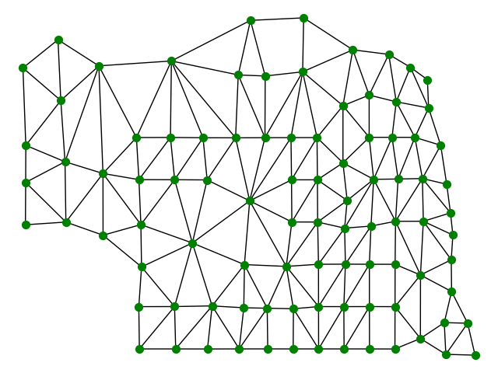

The set of neighbors of i ∈ V in the graph G is:

N(i) = {j ∈ V | {i, j} ∈ E}.

Using the following input data:

* the number of districts, k;
* the population, p, of each land parcel v ∈ V;
* the minimum and maximum population (L and U) allowed in a district.

Nebraska had a total population of 1,826,341 which must be split into k = 3 congressional districts of, about, equal population. Meaning the ideal district population is ̄p= 608,780.33. Since we cannot have a fractional population we must use 1% population deviation with a Lower(L) and Upper(U) bound of (+/−0.5%).

L = 0.995(608,780.33) ≈ 605,737

U = 1.005(608,780.33) ≈ 611,824.

For Nebraska L= [ ̄p] and U= [ ̄p], which means L= 608,780 and U= 608,781.

The counties should be split into districts such that:

1. Each county belongs to only one district;
2. There are k districts;
3. Each district, D, satisfies the population bounds;
4. Each district, D, is contiguous on the map.

**Hess model (moment-of-inertia compactness)**

We use the Hess model to make districts act as shapes with a centroid. It uses the following binary variable, where n = |V| is the number of counties.

xij = {1 if vertex i is assigned to district centered at vertex j

{0 otherwise.

The IP model is the following with the objective aiming to compact districting plans.

Min ∑i∈V ∑j∈V wijxij (1)

∑j∈V xij= 1 ∀i ∈ V (2)

∑j∈V xjj= k (3)

Lxjj ≤ ∑i∈V pixij ≤ Uxjj ∀j ∈ V (4)

xij∈ {0,1} ∀i, j ∈ V. (5)

Constraint (2) allows for each county to be assigned to only one district. Constraint (3) guarantees that k districts are chosen. Constraint (4) is to ensure the population of each district is between the Lower and Upper bounds. Counties from a district are located either at the centroid j, or elsewhere at location i at some positive distance dij from the centroid j.

**Adding Contiguity Constraints**

In order to impose contiguity, we can use a “flow” constraint. We create flow at each district’s center, send this flow along the district’s edges, and then consume one unit of flow at the district’s other nodes. It uses flow variables:

fijv = the amount of flow from center v, sent across from edge i to edge j.

In order to be contiguous, we use the following constraints.

∑u∈N(i) (fuij − fiuj) = xij ∀i ∈ V \ {j}, ∀j ∈ V (6)

∑u∈N(i) fuij ≤ (n−1) xij ∀i ∈ V \ {j}, ∀j ∈ V (7)

∑u∈N(i) fujj = 0 ∀j ∈ V (8)

fijv, fjiv ≥0 ∀ {i, j} ∈ E, ∀v ∈ V. (9)

Constraint (6) guarantees that if county i is assigned to center j, then i consumes one unit of flow of type j; otherwise, it consumes none of flow type j. Constraint (7) ensures that vertex i can receive flow of type j only if i is assigned to center j. Constraint (8) prevents flow circulations.

**Labeling model (cut edges compactness)**

The edges {i, j} ∈ E that are “cut” are those whose endpoints i and j belong to different districts. To minimize the number of cut edges, we use binary variables:

xij = {1 if vertex i ∈ V is assigned to district j ∈ {1,2,3}

0 otherwise.

ye = {1 if edge e ∈ E is cut

1. otherwise.

This leads to the following IP model.

min∑e∈Eye (10)

xuj−xvj ≤ ye ∀e = {u, v} ∈ E, ∀j ∈ {1,2,3} (11)

∑kj=1xij = 1 ∀i∈V (12)

L ≤ ∑i∈Vpixij ≤ U ∀j∈ {1,2,3} (13)

xij ∈ {0,1} ∀i ∈ V, ∀j ∈ {1,2,3} (14)

ye ∈ {0,1} ∀e ∈ E. (15)

The objective (10) minimizes the number of cut edges. Constraint (11) indicates that edge e = {u, v} is cut if vertex u, but not v ∈ V, is assigned to district j. Constraint (12) ensures that each vertex i ∈ V is assigned to one district. Constraint (13) ensures that each district’s population is between the Lower and Upper bounds.

**Adding Contiguity Constraints**

To impose contiguity, we will use a single-commodity flow (SCF) formulation. It will include flow variables fij and fji that are associated with each edge {i, j} ∈ E and it will include binary variable rij which indicates whether vertex i ∈ V is the root of district j ∈ [k].

∑i∈V rij= 1 ∀j ∈ {1,2,3} (16)

rij ≤ xij ∀i ∈ V, ∀j ∈ {1,2,3} (17)

∑u∈N(i) (fui−fiu) ≥1−M∑kj=1 rij  ∀i ∈ V (18)

fij+fji ≤ M(1−ye) ∀e = {i, j} ∈ E (19)

fij, fji ≥ 0 ∀ {i, j} ∈ E (20)

rij ∈ {0,1} ∀i ∈ V, ∀j ∈ {1,2,3}. (21)

Constraint (16) forces each district to have only one root. Constraint (17) states that vertex i ∈ V cannot root a district j to which it does not belong. Constraint (18) forces vertex i to consume flow if it is not a root. Constraint (19) does not allow flow to cross cut edges.

**6. Code**

See attached files.

**7. Experiments**

We computed the codes with and without contiguity to compare the differences of the resulting maps. In the moment of inertia without contiguity map, a county in District Two is separated from the rest of the district and in the moment of inertia with contiguity map, that county becomes a part of District One. Another difference between the two maps is that some counties switch to different districts. When we added GeoPandas and Contiguity to the min cut edges code it did not change the number of cut edges, but it did change which counties were a part of which districts and the populations in each district also changed. The computing attributes of the computer were: Ram was 16.0 GB and the processor was 2.20 GHz. We used Jupyter notebook version 6.1.4 and Gurobi Optimizer version 9.1.2. All models were solved and once started, Jupyter, ranged from 10-20 seconds to find a solution depending on the problem. The number of cut edges was 19.0, the absolute population deviation was 1 person, the moment of inertia objective was 8571582443.0757 with contiguity, and the total perimeter length (excluding the exterior boundary of state) was 5.2755. The populations in each of the districts were 608,839 for District One, 609,327 for District Two, and 608,175 for District 3.

**8. Maps**

**8.a. Original Nebraska Current Political Districts as of March 22, 2021**

This map shows District Two with two counties, one of them being Sarpy which is split between District One and Two, violating the political division integrity constraint.

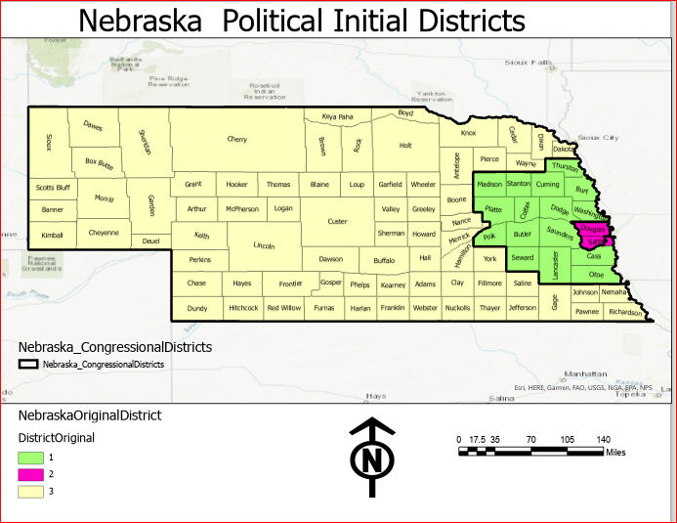

**Close up of District Two**

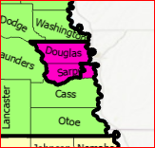

**8.b. Map Political Districts without Contiguity**

The following map shows the result before imposing contiguity constraints. Washington county shows the need for a contiguity constraint to avoid discontinuity in District Two.

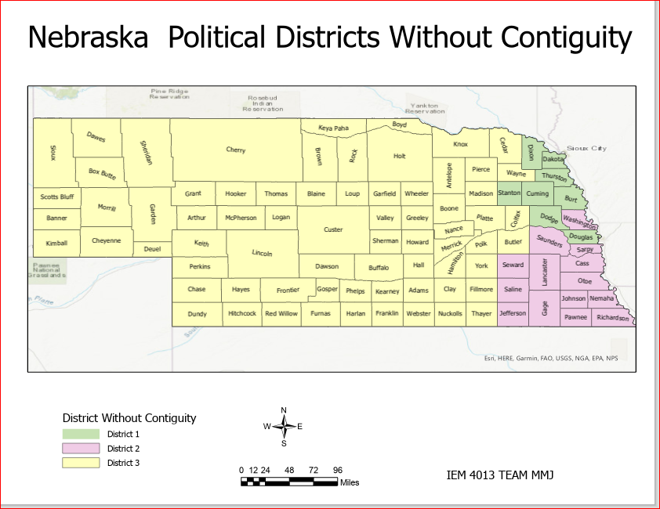

**8.c. Map Political Districts with Contiguity**

In this map, we see the effect of the contiguity constraint. Washington County moves to District One and the integrity of counties is preserved.

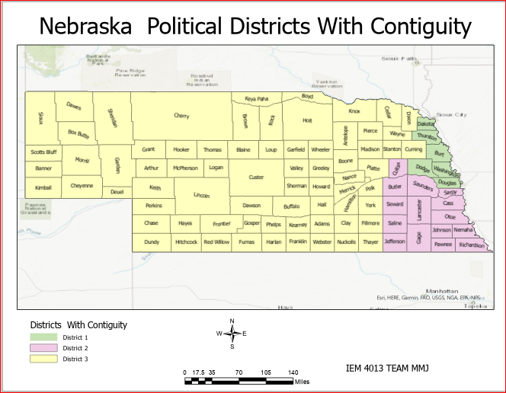

**8.d District Distribution**

**District One: Six counties**

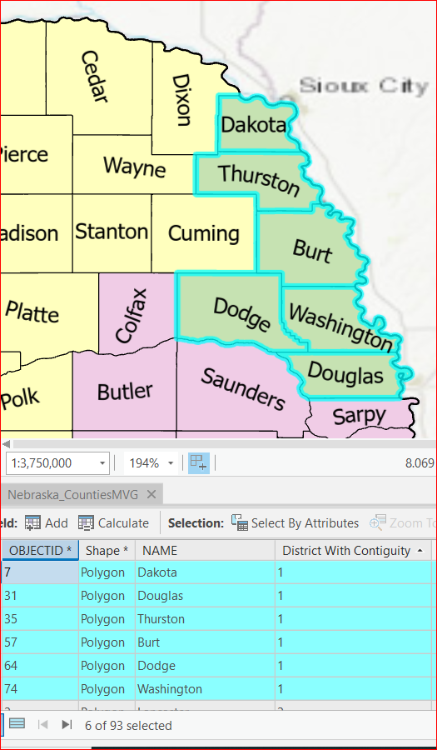

**District Two: 15 counties**

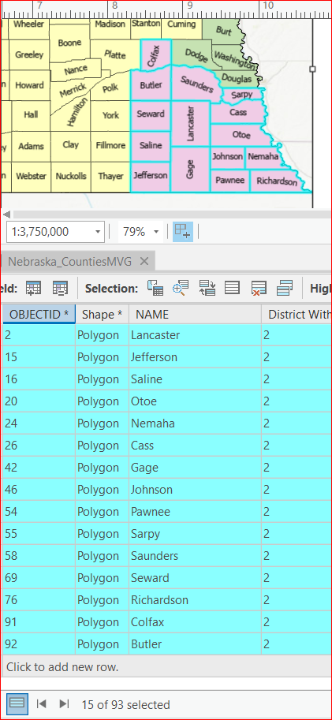

**District Three: 72 counties**

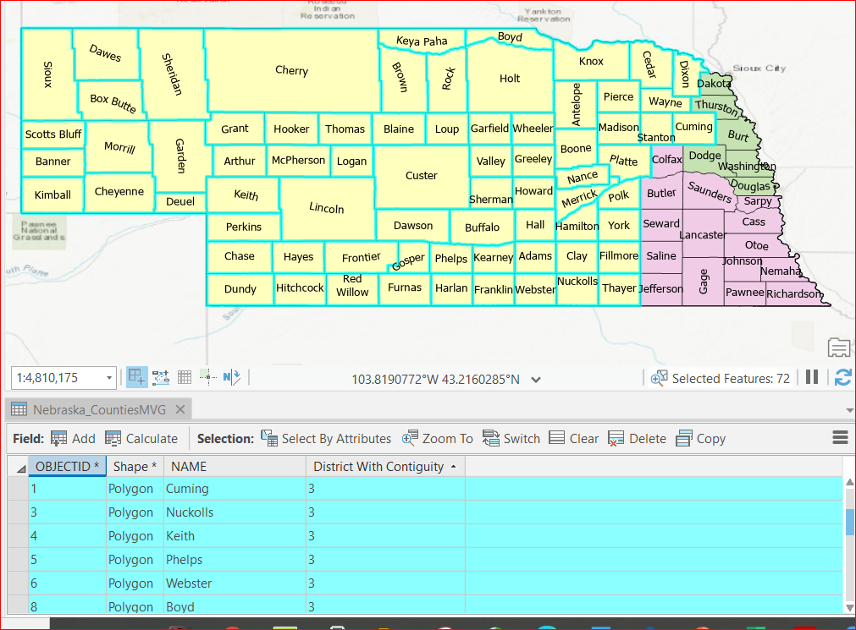

**9. Evaluation of Plan**

The final map was able to meet Nebraska’s requirements of compactness and contiguity. It also holds the core of prior districts as it is not a drastic change from the 2010 map. We used the counties to assure we preserved the current political subdivision as the counties themselves serve as current subdivisions. The map does not avoid pairing incumbents as that is not required for the state of Nebraska. The requirement of avoiding favoring a political group may or may not be met with the proposed map. The issue is caused by the lack of data and demographics used to create the map. Therefore, we could not impose any constraints to avoid favoring political groups or candidates. So, we do not know if political groups are favored in the maps or not. In summary, the proposed map does meet Nebraska's state and federal requirements, with the only exception being the favoring of political groups.

**10. Conclusion**

With the models we developed we found that there is room for improvement compared to the current district subdivisions. We identify changes from the current district map (8.a) to the final version (8.c). The number of counties in the new districts should be 6 for District One, 15 for District Two, and 72 for District Three. It is important to note the county of Sarpy was split between Districts One and Two, but our proposed map places Sarpy solely in District Two. The population in each of the new districts is 608,839 for District One, 609,327 for District Two, and 608,175 for District Three. Another important issue that the model identified and corrected for was the integrity of the counties because it assigned Sarpy as a whole to District Two, eliminating the split problem. In summary, we found the state of Nebraska could take further steps to improve their current political districts.

**References**

Ballotpedia.orghttps://ballotpedia.org/Redistricting_in_Nebraska_after_the_2020_cens us), retrieved 03/21/2021

Buchanan, Austin. 2021. Two MIPs for redistricting. IEM 4013 OSU Stillwater.

Herbert, G., Smith, P., Vandenberg, M., DeSantis, M. 2010. The Realist’ guide to redistricting: avoiding the legal pitfalls. Second edition. Ababooks.org

NCSL.org https://www.ncsl.org/research/redistricting/districting-principles-for-2010- and-beyond.aspx) retrieved 03/21/2021 https://www.ncsl.org/research/redistricting/redistricting-criteria.aspx#, retrieved 03/21/2021